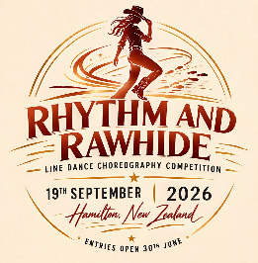

Choreography Entry Form
19th September Hamilton
Rhythm and Rawhide Choreography Competition 2026

Entries Close 6th August 2026
One form per dance entry
Maximum of 2 entries per choreographer

CONTACT DETAILS:
Name: ________________________________________________________________________
Phone: _______________________________________________________________________
Email: ________________________________________________________________________

DANCE DETAILS:
Choreographer(s): ______________________________________________________________
Dance Name: __________________________________________________________________
Level of Dance: ________________________________________________________________
Song Title: ____________________________________________________________________
Artist: ________________________________________________________________________

A Condition of Entry Form must be completed for all dancers & submitted with this Entry Form
Email completed entry forms to nzlinedancer@outlook.com
PLEASE DIRECT ANY QUERIES TO Event Director Jo Price: nzlinedancer@outlook.com

